**Face Detection and Recognition Model Implementation**

Abstract:

This project develops a face recognition system using a neural network for recognition and Dlib for face detection. A Jupyter Notebook integrates data preprocessing, feature extraction, model training, and evaluation to deliver an accurate and efficient face recognition solution.

Keywords:

* Face Recognition, Neural Networks, Dlib , Face Detection, Image Processing, Machine Learning etc.

**Dataset collection:**

The data set taken from the Kaggle has 20 images

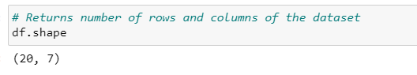

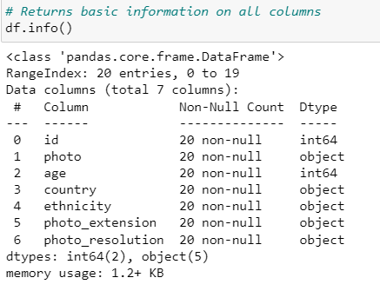

Dataset link:<https://www.kaggle.com/datasets/trainingdatapro/male-selfie-image-dataset>

Install Packages :

Install packages like Face-detection, OpenCV-python-headless, NumPy, Matplotlib, etc.

**Face Detection**:

**Detect faces in an image**: Use a face detection model to identify faces in an image and draw rectangles around them.

**Feature Deletion:**  
Take features apart from the faces detected: To convert facial traits into numerical vectors that can be compared, use a feature extraction model.  
**Face Detection:**  
Compare the identified faces in the dataset with the faces that have been labelled: To locate matches, compare the retrieved features of the identified faces with known faces.

Rectangles are drawn, and faces that have been identified are marked with rectangles and, if known, with names.

**Data normalization:**

Data normalization scales features to a common range or distribution, ensuring consistent input for machine learning models and improving performance.

**Output:**

Detected and recognized faces are displayed with rectangles around them, showing names if recognized

Facing Issues: My system Karnal is dead and I'm executing the code system not supporting because system configurations are different.